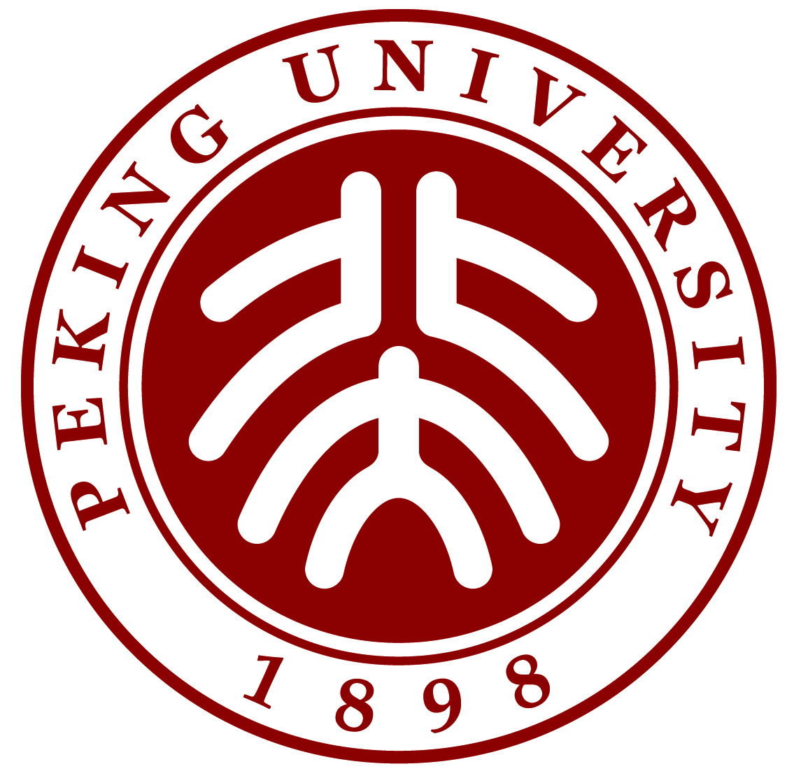
Study Plans for the Duration of Exchange @ PKU
(For general visiting students ONLY)
Name:
Home University
Duration of Exchange | From__________(MM)___________(YYYY) to___________(MM)___________(YYYY)
Chinese Language Proficiency: | Reading: □native speaker □fairly (equivalent to HSK Level 6)  □daily use (equivalent to HSK Level 2-5) □Beginner □None
Speaking: □native speaker □fairly (equivalent to HSK Level 6)
□daily use (equivalent to HSK Level 2-5) □Beginner □None
Writing: □native speaker □fairly (equivalent to HSK Level 6)
□daily use (equivalent to HSK Level 2-5) □Beginner □None
Listening: □native speaker □fairly (equivalent to HSK Level 6)
□daily use (equivalent to HSK Level 2-5) □Beginner □None
 | Years of learning Chinese | _______ years
Study Plan:  (single choice) | □(1) Only take Chinese language training courses.  Please select “School of Chinese as a Second Language (对外汉语教育学院)” when completing the online application.  □(2) Take mixture courses: Chinese language training courses (18-20 class hours/week) + English-taught subject courses (≤6 credits in total).  Please select “School of Chinese as a Second Language (对外汉语教育学院)” when completing the online application.  □(3) Give up Chinese language training courses and only take subject courses with Chinese students (Chinese-taught/English-taught)  Please select “other departments/schools (专业院系)” when completing the online application.
* Note: This study plan is designed for the incoming semester. If you will study at PKU for two semesters, please choose your plan of the first semester.
Signature (1) of student: _______________
Terms and Conditions
- For Chinese-taught courses, high-level Chinese Language proficiency is required. Students who are native speakers or have a new HSK Level 6 certificate can take Chinese-taught courses at PKU departments/schools. Students who fail to provide HSK Level 6 scores SHOULD first test their Chinese proficiency on their own by trying PKU MOOC courses online at http://mooc.pku.edu.cn/mooc/ , and then make decision on their study plan.
For English-taught courses, evidence of English language proficiency is not required to provide.
- Students who choose the 3rd option [i.e. studying subjects at other departments/schools (专业院系)] are NOT allowed to change to Chinese language learning upon registration.
- University-wide exchange students are allowed to take English-taught courses of no more than 6 credits each semester in total while studying Chinese.
- Students studying subjects are required to take courses of no less than 6 credits and no more than 20 credits each semester in total.
Students studying Chinese at the School of Chinese as a Second Language must take a course load of 18 academic hours per week minimum.
- Students studying subjects normally take undergraduate courses university-wide (across departments). If Chinese-taught graduate courses are needed, they should get approval from the relevant department. English-taught courses of special Master programs (MBA, Master in International Relations, Master in Public Policy, LLM in Chinese Law, Yenching Academy, etc.) are NOT open to exchange students.
- Students studying subjects should obey the principle of resource priority. Degree-seeking students of Peking University have priority in selecting courses. Courses provided by special programs first meet the demands of their students. The departments/schools reserve the right of explanation and final decision.
- Students studying subjects may take one advanced elective Chinese language course (HSK Level 5-6) at SCSL only if there is space available. Elementary and intermediate elective Chinese language courses at SCSL are NOT open to students of other departments.
- Some courses are not offered every semester, and the courses that the student wants to read or needs to read may not be available for them.
- It is the responsibility of students to check and ensure that they have done course matching and the credits can be transferred back to their home university.

I have read and understood the above terms. I agree with these terms for the duration of my exchange at PKU.

______________________
Signature (2) of student
Date: _________________

