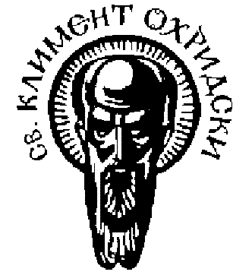

**LLP/Erasmus Staff Training Week**

**European Universities without Borders: Erasmus for All**

**15 – 19 October, 2012**

**Sofia University St. Kliment Ohridski**

**Draft Programme**

* **Monday, 15th October**

Morning Arrival and registration of participants

Presentation of Sofia University St. Kliment Ohridski

Presentation “European Universities without Borders: Erasmus for All” – strategic initiative

Who’s who? – introduction of participants (without PP)

Afternoon Introduction to the Bulgarian Language

Rectorate tour (Library, Museums, etc.)

Evening Welcome Dinner

* **Tuesday, 16th October**

Morning Presentation of the Bulgarian History

Workshop on Best Erasmus Practice and European Projects Coordination – Part I

Institutional lunch

Afternoon Workshop on Best Erasmus Practice and European Projects Coordination – Part II

Cultural guided tour of Sofia

* **Wednesday, 17th October**

Morning Presentation “Bologna Process”

Presentation of ESN Bulgaria, Exchange Erasmus students at Sofia University, Practical aspects of incoming student mobility

Afternoon Presentation “Staff Training – close cooperation between HEI’s

Creation of ERASMUS forest (planting of 25 young trees with the participants’ national flags)

Evening Visit of the University’s Theater

* **Thursday, 18th October**

Morning Presentation “Internationalization of Higher Education”

Bulgarian folkdances for beginners

Afternoon Meetings with Faculty Erasmus coordinators (on preliminary appointment)

Visit to the National Historical Museum in Boyana and Boyana Church

* **Friday, 19th October**

Morning Presentation of a representative of the National Agency in Bulgaria (Human Resource Development Center)

Presentation of a representative of the Unit of Higher Education: Erasmus – European Commission (Erasmus for All/ Learning Mobility, Institutional Cooperation, policy support)

Evaluation and closing of the staff training week;

Farewell lunch